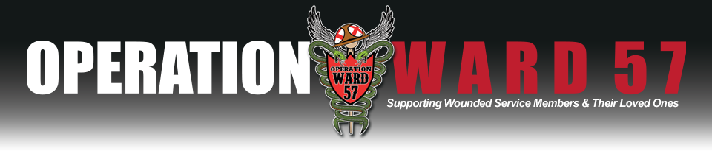

For Immediate Release
November 1, 2015
Contact:
Brittney Hamilton
info@operationward57.org
253-534-8779

Operation Ward 57 Announces Availability of Amputee Teddy Bears for Wounded Warrior Families

Seattle, WA - Operation Ward 57 is excited to announce they have partnered with The Freeman Project and students at St. James High School in Murrells Inlet, SC to provide custom Amputee Teddy Bears to children of wounded warriors around the country! These teddy bears are not only provided as a comfort and emotional support item, but they are an educational tool as well. The amputee teddy bear they receive will be custom made by hand to match their wounded warrior.
The bears can be customized with specific arm or leg amputations, military branch uniform and custom nametape.
These bears will be provided FREE of charge to the families.
Those Eligible Include Post 9/11 Active Duty Service Members or Veterans who suffered the loss of a limb in combat or as a result of injuries sustained while deployed. Priority in production goes to those still in the hospital in recovery.
To Sign Up Please go to: http://www.operationward57.org/amputeebear/

Read more about all of these great groups here:
Meet Lisa Freeman and The Freeman Project:
Lisa Freeman founded The Freeman Project after she experienced the nightmare every mother fears: the death of her son. August 7, 2009 she was teaching "her last first day of school" after 30 years of teaching. She was talking about her family and asking the students if they'd like to start a project to send school supplies to her son in Afghanistan to give to the local Afghan children. Moments later, Marines were escorted down the hall to her room to tell her Matthew had been killed.

By Memorial Day, 2010, with the help of many friends, she started "Pens and Paper for Peace". Over the next 4 years, they sent over 16,000 pounds of school supplies to soldiers and Marines to give directly to the children. However, as the war wound down, it became almost impossible to give the supplies directly to the children. She began looking for other ways to impact our military.

TAPS (Tragedy Assistance Program for Survivors) suggested helping siblings of the fallen. This led to two scholarships: Capt. Matthew C. Freeman, USMC, Memorial Sibling Scholarship and Capt. Matthew C. Freeman, USMC, scholarship for Siblings of Combat Related Suicide Loss. The siblings have been labeled the "forgotten mourners". Both of her daughters delayed their education due to Matthew's death, so they felt this was a wonderful way of recognizing the sibling's loss.

About this same time, a young woman came to Lisa to talk about her fallen brother. She had not received anything of his after his death. His wife was not ready to give up anything. Lisa’s cousin's church had made teddy bears out of Matthew's uniforms for all of his nieces and nephews and it meant so much to her daughters. Lisa suggested she ask her sister-in-law for some uniforms and she could make bears for her brother's daughters and her own three boys. A month later she sat in Lisa’s living room with the uniforms. They launched "Matthew Bears" (based on Matthew 5:4, "Blessed are those who mourn, for they shall be comforted") in February 2014. In the first year, with the help of over 200 seamstresses across the country, they made over 300 bears for families of the fallen and families of combat related suicide loss.

Recently, Lisa received a request to make bears for children of amputees through Operation Ward 57. The same day, she received a message from a teacher, Laura in South Carolina, who wanted to help make bears and involve her students in the project. It seemed a perfect match!

Lisa says “I know my son is smiling down at the volunteers offering to make the bears and the children who receive them. May God continue to bless everyone involved.”

Meet Laura Coffren & The FCCLA Students at St. James High School in Murrells Inlet, SC:
Laura Coffren is currently a Family and Consumer Science Teacher at St. James High School in Murrells Inlet, SC. She is going into her 4th year there. Previously she had been a teacher and then a Vice Principal in Southern Maryland and retired after 31 years.
Her passion is sewing and she loves getting her students involved in sewing not only for themselves but for others. They have a small group of students who are involved in FCCLA – Family, Career and Community Leaders of America. She wants them to understand how they can impact their community and become leaders that make a difference.
So far they have had several meaningful opportunities to be involved in a variety of projects:
- Every year they sew close to 50 Christmas Stockings for their school sponsored Angel Tree for the less fortunate children in their community and then they encourage the students and faculty at school to fill them. They also had an opportunity to make stockings for a group of soldiers overseas which the faculty filled for them.
- They have made baby bonnets for newborn children and presented them to a local hospital.
- They made a pink out quilt, raffled it off and were able to give $565.00 to Relay for Life.
- They have made 100 cloth teddy bears for the local and county police department so they can give them out to children who are in a difficult or stressful situation.
Recently she saw a story about the Freeman Project and decided that since it is the beginning of a new year that this could be the perfect opportunity to be involved in such an honorable project. She contacted Lisa and she immediately responded with her own amazing story about her son Michael as she was also a teacher which gave them an immediate kinship. Within a week Lisa received an email from Pamela King with Operation Ward 57 based out of Walter Reed Medical Center. Pamela was asking if it were possible for Lisa to have amputee teddy bears made for the children of these soldiers. Lisa immediately thought of Laura and that it would be an invaluable experience for her students and Laura says she couldn’t agree more. She believes that opportunities present itself when you least expect it and at a time when it is meant to be.
Laura and her students are very honored and proud to represent Operation Ward 57 and the service men and women who have given such sacrifices for our country.

Meet Operation Ward 57:
Walter Reed National Military Medical Center (WRNMMC) in Bethesda, MD is the first stop for many of America’s returning wounded service members from Iraq and Afghanistan. Known as “the amputee ward”, historically the orthopedic Ward 57 at Walter Reed Army Medical Center, now 4 East, houses some of the most severely injured patients for weeks or even months. Operation Ward 57 was founded in 2007 to provide direct support to those in recovery.
Operation Ward 57 supports wounded, injured and ill service members, veterans, their caregivers and those that aid in their recovery by providing assistance and outreach in their recovery, comfort and morale, and through advocacy, education and promotion of their circumstances. Learn more at www.operationward57.org. Tax ID 61-1521946

###

